Moviri Technical Challenge

Version: 1.1

Date: May 24, 2021

# Table of Contents

1 Table of Contents 2

2 Instructions 3

2.1 Welcome! 3

2.2 Rules of Engagement 3

3 Technical Challenges 4

3.1 Coding Exercise 4

3.1.1 Input 4

3.1.2 Expected Output 4

3.1.3 Example 4

3.2 SQL QUERY 5

3.2.1 Input 5

3.2.2 Expected Output 5

3.2.3 Example 6

# Instructions

## Welcome!

Thank you for your interest in joining Moviri! Moviri is always looking for talented individuals to join our team of Performance Engineers. We are passionate about what we do, and we want to share this passion with you!

It is important for us to have our newcomers speak the same technical language. To verify this, we have created a set of two tests for you to complete as the next step in the application process.

Once you completed the challenges, please submit your results to Kemi Fadarey at [usjobs@moviri.com](mailto:usjobs@moviri.com).

We wish you the best of luck!

-Moviri Team

## Rules of Engagement

The sections below contain two exercises that must be completed within 7 days.

* For the CODING EXERCISE, you will be asked to create a small procedure combining information from two CSV files. You can develop the source code in any coding language (Java is preferred, R is not admitted as an option) without using any external Framework (e.g. Pandas). To complete the assignment, you need to share the following with us:
  + The Source Code of the procedure that you created
  + A screenshot showing the procedure output
* For the SQL QUERY EXERCISE, you will be asked to create a SQL query and execute that on an SQLite database that we will provide to you. To complete the assignment, you need to share the following with us:
  + The SQL Query that you created for the assignment
  + A screenshot showing the output of the executed SQL Query

# Technical Challenges

## Coding Exercise

This section contains the CODING EXERCISE. For this assignment, you will be asked to create a small procedure combining information from two CSV files You can develop the source code in any coding language (Java is preferred, R is not admitted as an option) without using any external Framework (e.g. Pandas). To complete the assignment, you need to share the following with us:

* The Source Code of the procedure that you created
* A screenshot showing the procedure output

### Input

In the shared archive file, you will find two CSV (Comma Separated Values) files.

* A file named “*bandwidth.csv*”, containing the Bandwidth information for a set of Network Interfaces. A Network Interface is identified by the couple [server, network interface name]
* A file named “*netbitrate.csv*”, containing the Network Bit Rate registered for the same set of Network Interfaces over a period. A Network Interface is identified by the couple [server, network interface name]

### Expected Output

You are asked to develop a small procedure that, given the two CSV files, calculates the Network Bandwidth Utilization for every line in the “*netbitrate.csv*” file. The Network Bandwidth Utilization of an interface is calculated as the Network Bit Rate divided by its Bandwidth. The procedure needs to print the results on the standard output according to the following format:

*Timestamp | Server | Network Interface | Network bit rate / Bandwidth*

*Hint: Please ensure that your solution considers floating point numbers*

### Example

**Inputs:**

File: “bandwidth.csv”

Server, InterfaceName, Bandwidth

server1,eth0,10

server1,eth1,20

server2,eth0,10

File: “netbitrate.csv”

Timestamp, Server, InterfaceName, NetBitRate

2019-07-08 21:53:27,server1,eth1,100

2019-07-06 23:10:54,server1,eth0,200

2019-05-10 03:36:22,server2,eth0,150

2019-01-14 13:14:51,server2,eth0,50

2019-05-01 19:47:33,server1,eth1,80

**Output:**

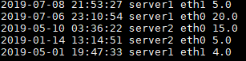

## SQL QUERY

This section contains the SQL QUERY EXERCISE you will be asked to create a SQL query and execute that on a SQLite database that we will provide you. To complete the assignment, you need to share the following with us:

* The SQL Query that you created for the assignment
* A screenshot showing the output of the executed SQL Query

### Input

In the shared archive file, you will find two files:

* A file named “*moviri.sqlite.db*”, containing an SQLite Database, where the query needs to be executed
* A file named “*moviri.sqlite.db*”, showing the schema of the SQLite Database

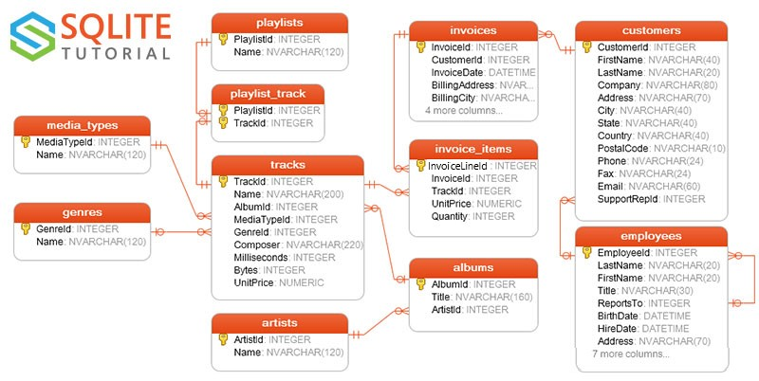

### Expected Output

You are required to create a SQL query retrieving **all** employees and the respective sum of invoice totals for the customers they support. Please order the result set in descending order by the total invoice sum.

*Hint: if they did not support a customer then we expect NULL value*

### Example

